INSTRUCTIONS FOR USING Astrometrica

I. INTRODUCTION

YOU are the key to the success of your citizen scientists in the search for asteroids.

There are three things you must master, and if you do, your citizen scientists will make important measurements of near-Earth objects and might discover a Main Belt asteroid or two as they participate in an IASC asteroid search campaign. You must:

1. Be able to use Astrometrica to conduct a manual search.
2. Be able to distinguish between a true and false signature for moving objects.
3. Be able to prepare a clean and accurate Minor Planet Center (MPC) report.

Once you have Astrometrica up and running on your computer, it will take a couple hours of your time to master the above tasks. They are not difficult to do. But, you must prepare yourself ahead of time before receiving image sets in an IASC asteroid search campaign.

In this document you will find instructions on how to do a manual search using Astrometrica. You will learn how to prepare a clean and accurate MPC report.

To learn how to distinguish between a true and false signature for a moving object, you need to review the document entitled True vs. False Signatures. This is very important.
Measuring and reporting false signatures is the most common mistake made by citizen scientists as they first learn to search for asteroids.

Citizen scientists often confuse what appear to be moving objects on the images (e.g., hot pixels, background fluctuations) with asteroids. Not all things that appear to move on the images will actually be asteroids. They must learn to know the difference and only measure asteroids (i.e., true signatures) and not the false signatures.

II. MANUAL SEARCH – BLINK UTILITY

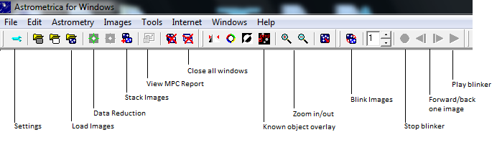
- Start Astrometrica. The following is the Astrometrica menu bar with its various functions:

- Astrometrica may ask you to overwrite the MPC report. Click “Yes” only if you have completed the MPC report. Click “No” If you have not completed the search on the image.
- Verify and change as necessary the configuration file used to analyze the image. The name of the configuration file is found on the bottom right hand corner of the screen. It should be PS1.cfg for all of the images, because our images come from the PanSTARRS telescope.



To change the configuration file select Settings on the menu bar. Click “Open” and select the correct configuration file from the program files, then click “OK.”
      - Download your image set from the IASC home page and unzip onto the Desktop or designated folder. In Astrometrica select Load Images on the menu bar and load your image set (3 or 4 images per set), and click “Open”. After each image opens, a box will appear; click “OK” each time.

- Select Data Reduction on the menu bar, and select OK in the box that appears. This function will find reference stars in your images.

- Select Known Object Overlay on the menu bar, then select the Blink Images button and zoom in twice to enlarge the image.

- Visually scan the blinking image for moving objects.

MANUAL MEASUREMENT:

- When a moving object is detected, select Stop Blinker on the menu bar.
- Begin by forwarding to Image 1, by clicking on the Forward or Back button.
- Center the object with the cross-hair and click on the object.
- Click on Object Designation and check for an object close to 0.00 in declination and right ascension, then select that object and click “OK”, then click “Accept”. If there is not an object close, then give the object a name by typing 3 initials to represent your citizen science group and a 4 number designation.

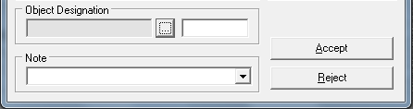

*The name must consist of 3-letters 4-numbers. For example Hardin-Simmons University might enter HSU0001 for the first discovery, HSU0002 for the second discovery, and so on. This must
be a unique name for each discovery during a 30-day campaign. No spaces are allowed in the name!

- Repeat the procedure for images 2, 3, and 4 by forwarding to Image 2 and then to Image 3, and finally to Image 4, repeating the same procedure as with Image 1.

- Continue searching the image until all asteroids have been measured.

III. MINOR PLANET CENTER (MPC) REPORT

- One MPC report must be prepared for each image set and sent as an email attachment to: iascsearch@hsutx.edu . If more than one group of citizen scientists analyzes the image set, only send in one report listing up to five people.

- Open a text document such as Notepad. (Not Microsoft Word).

- In Astrometrica, select the View MPC Report from the file menu. Copy and paste the MPC report into Notepad.

      - Replace “T. Vorobjov, PS1 Science Consortium” in the MEA line with the first initial and last name of the citizen scientists analyzing the image, followed by the group name and country in parentheses. Up to five citizen scientists may be included in each report. Do not change the OBS line.
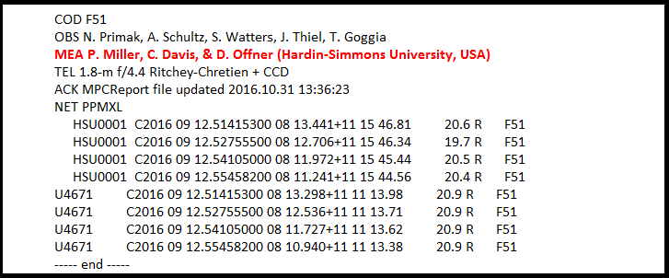

- Add the complete name of the image set and space out the asteroid data.
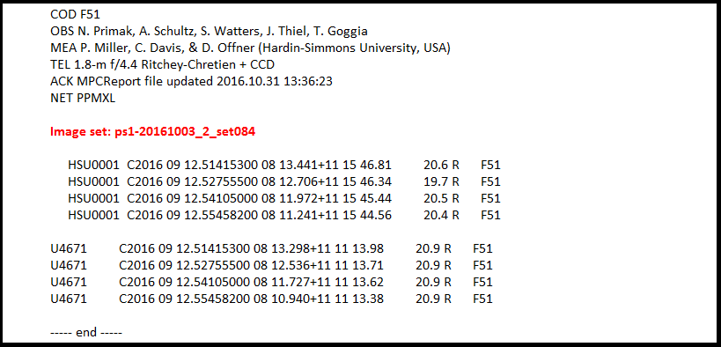

MPC REPORT FOR AN IMAGE SET WITH NO MOVING OBJECTS FOUND

If an image set does not have any moving objects detected, an MPC report must still be prepared. When you have an image set that has no moving objects and create the MPC report the heading needs to be complete with the image set name and citizen scientist names included. To get the complete heading you need to click on “something”, (any star will do) in the image and take a measurement, assign it a generic designation number like xxx0000 . This will create the full header in the MPC report. When you copy and paste to Notepad, you can delete the measurement and add the line “No moving objects detected”. The report should look similar to the one below.

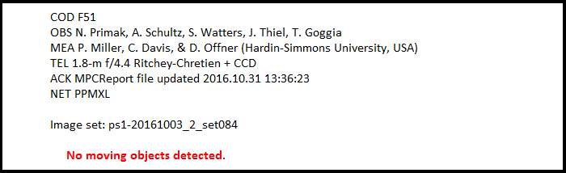

Email all completed MPC reports, as an attachment, to Dr. Miller at iascsearch@hsutx.edu. Do not send the MPC reports to any other location!!

